`

Moorpark College Athletics
Concussion/mTBI Management Protocols



Cherisse Meichtry
June 2017

Concussion/mTBI Management Guidelines
- Moorpark College athletics will require student-athletes to sign a statement in which they accept the responsibility for reporting their injuries and illnesses to the athletic training staff, including signs and symptoms of concussion/mTBI (mild traumatic brain injury) (Attachment A). During the review and signing process student-athletes will view an educational video on concussions/mTBI’s and be provided with educational materials on the signs and symptoms on concussions/mTBI’s (Attachment B and/or CDC Concussion statement).

- MC will have on file an emergency action plan to respond to student-athlete medical emergencies; including but not limited to concussions/mTBI’s, heat illness, cardiac arrest, spine injury, respiratory distress (e.g. asthma), musculoskeletal injury and sickle cell trait collapses. All athletics health care providers and MC athletic staff shall be informed and review the plan during annual staff meetings. These sessions will be conducted prior to the start of the athletic season. Staff will sign that they have received a copy and understand the concussion/mTBI Management Protocols as well as the Athletic Emergency Procedures. The signatures will be kept with the athletic trainers.

- MC athletic training staff members shall be empowered to determine management and return-to-play of any ill or injured student-athlete, as he or she deems appropriate. Conflicts or concerns will be forwarded to Cherisse Meichtry (Athletic Trainer) and Pierre Durand, MD (Team Physician) for remediation.

- MC shall have on file a written concussion/mTBI management plan that specifically outlines the role of athletics healthcare staff (e.g., physician, certified athletic trainer, nurse practitioner, physician assistant, neuropsychologist). In addition, the following components have been specifically identified for the collegiate environment:

  - MC coaches will receive a copy of the concussion/mTBI management protocol, a fact sheet on concussion/mTBI in sport, and educational session on concussion/mTBI management to include viewing an educational video (Attachment C).

  - MC athletic training staff and other athletics healthcare providers will practice within the standards as established for their professional practice and follow the California Community College Athletic Association Bylaw 9.6 (Attachment D) on concussion/mTBI management.

  - MC will record a baseline assessment for each student-athlete participating in a collision and/or contact sport (baseball, basketball, football, soccer, softball) at a minimum. In addition, a baseline assessment will be recommended for student-athletes with a known history of concussion/mTBI. The same baseline assessment tools should be used post-injury at appropriate intervals. The baseline assessment should consist of the use of: 1) a self-reporting symptom checklist, 2) the Balance Error Scoring System (BESS), and 2) neuropsychological testing (computerized ImPACT test). Neuropsychological testing has been shown to be effective in the evaluation and management of concussion/mTBI. The neuropsychological testing program should be performed in consultation of a physician and or neurologist when needed. Post injury neuropsychological test data will be interpreted by a physician/neurologist prior to return to play. Neuropsychological testing has proven to be an effective tool in assessing neurocognitive changes following concussion/mTBI and can serve as an important component of an institution’s concussion/mTBI management plan. However, neuropsychological tests should not be a used as standalone measure to diagnose the presence or absence of a concussion/mTBI as MC uses a comprehensive assessment by its athletic training staff.

  - When a student-athlete shows any signs, symptoms or behaviors consistent with a concussion/mTBI, the student-athlete will be removed from practice or competition, by either a member of the coaching staff or athletic training staff. If removed by a coaching staff member, the coach will refer the student-athlete for evaluation by a member of the athletic training staff. Attachment E will be the form used for evaluation of concussion/mTBI. During competition, on the field of play injuries will be under the purview of the official and playing rules of the sport. MC staff will follow such rules and attend to medical situations as they arise. Visiting student-athletes evaluated by MC athletic training staff will be managed in the same manner as MC student-athletes.

  - A student-athlete diagnosed with a concussion/mTBI will be withheld from the competition or practice and not return to activity for the remainder of the day. Student-athletes that sustain a concussion/mTBI outside of their sport will be managed in the same manner as those sustained during the sport activity.

  - The student-athlete will receive serial monitoring for deterioration. Student-athletes will be provided with a written Head Injury Warning Instructions paper (Attachment F) upon discharge; preferably with a parent, guardian, roommate or someone that can follow instructions.

  - Once diagnosed with a concussion/mTBI, if the student-athlete is advised to stay home and rest, their instructors will be notified either by email, or concussion awareness letter (Attachment G).

- MC will document the incident, evaluation, continued management, and clearance of the student-athlete with a concussion/mTBI. Aggregate concussion/mTBI numbers per sport will be reported to the Director of Athletics as requested.

- Athletic staff, student-athletes and officials will continue to emphasize that purposeful or flagrant head or neck contact in any sport should not be permitted.

Approved by: Team Physician Date:
Pierre Durand, MD
Approved by: Dean of Athletics Date:
Lisa Putnam
Approved by: Athletic Director Date:
Vance Manakas, MS, ATC
Approved by: Athletic Trainer Date:
Cherisse Meichtry, MS, ATC

MC Concussion/mTBI Management Plan

Obtain Baseline Testing: Symptom check, BESS, and IMPACT testing data obtained for student-athletes in high-risk sports for concussion/mTBI (baseball, basketball, football, soccer and softball) or with pertinent medical history of concussion/mTBI.

Concussion/mTBI Identified and Assessed: Physical examination and assessment of concussion/mTBI symptoms by medical staff (Athletic Trainer, MD, College Nurse); student-athlete withheld from all physical activity; any life threatening head injury should be transported to the emergency room immediately; given Head Injury Warning Instructions sheet; notify parent/guardian of concussion/mTBI. Student-athlete will repeat all baseline testing within 48 hours post injury or when deemed appropriate.

Concussion /mTBI Management: Student-athlete withheld from all physical activity; re-assessment of student-athlete daily by medical staff until completely asymptomatic; perform BESS test routinely; notify academic advisor for possible consideration of academic modifications or restrictions.

Student-Athlete Asymptomatic: Student-athlete repeats baseline testing (IMPACT) and BESS test (unless directed otherwise by physician and or/neuropsychologist)

Test Results NOT Returned to Baseline: When not medically cleared by physician, repeat test battery; consider neuropsychologist consult with more detailed test battery
Test Results Return to Baseline: Complete Return to Play Protocol: re-evaluation by physician for return to play decision

When medically cleared by physician, repeat Return to Play Protocol; re-evaluation by physician for return to play decision

Return to Play Protocol Following Concussion/mTBI
IMPACT & BESS Testing

Once you are symptom-free, you may progress the following day to the next step. Day 1 is the day following the 1st symptom-free day, each step takes 1 day!

1) NO activity, complete rest. If advised, stay home from school, and no school work or studying.
2) Light aerobic exercise such as walking or stationary cycling. No resistance training.
3) Sport specific exercise – for example, skating and puck handling in hockey, running and ball
skills in soccer (NO HEADING), quarterbacks may resume sideline throwing. An important
portion of this step is the addition of one set of low resistance or simple resistance training.
4) Resume non-contact training drills; for example, walk-through pass blocking for
football linemen. Add additional sets and higher intensity resistance training.
5) Full contact practice after receiving medical clearance. Do not skip this important step.
6) Game play

If no change or increase in symptoms, move to next step on the following day

*Return To Play Protocol may be modified depending on sport and athlete conditioning

If any post-concussion/mTBI symptoms develop at any stage, drop back to the
previous level and try to progress again after 24 hours. No medications may
be taken at any step of the progression. This is to prevent masking a more
serious underlying condition! You must check in with your athletic trainer
every day PRIOR to practice!

Return to Play – following medical clearance

Attachment A

Guidelines for Concussion/mTBI (Mild Traumatic Brain Injury) Management
The Moorpark College Athletic Training Team has established the following guidelines, which are recommended by the CCCAA, NCAA, NATA, ACSM, and CDC, in the management of all suspected concussions/mTBIs.

- Student-athletes must sign a statement in which they accept responsibility for reporting their injuries and illness to MC athletic training staff; including signs and symptoms of a concussion/mTBI.
- Student-athletes will be presented with educational materials on concussions and concussion/mTBI management.
- MC athletics will have on file an appropriate healthcare plan dealing with athletic injuries.
- MC athletic training staff (MD’s, AT’s, PA’s, College Nurses) are empowered to have Unchallengeable Authority to determine management and return to play decisions for student-athletes.
- Student-athletes participating in high contact/collision sports: baseball, basketball, football, soccer, softball, who are in-season will have a neuropsychological baseline established using the ImPACT test prior to practicing. A Balance Error Scoring System (BESS) test and symptom checklist will also be completed in conjunction with the ImPACT test to establish a baseline for participants prior to the season.
- This same baseline testing will be done for participants with a history of concussion/mTBI.
- Coaches and student-athletes suspecting a student-athlete of having a concussion/mTBI should report the injury to the athletic training staff as soon as possible.
- Student-athletes suspected of having a concussion will be assessed by a health care provider as soon as possible.
- Symptoms of concussion/mTBI are grounds for immediate removal from contest and evaluation by appropriate healthcare professional.
- The diagnosis of concussion/mTBI yields a minimum one day removal from athletic participation.
- The student-athlete should receive serial monitoring of signs and symptoms.
- Written instructions will be provided to the student-athlete, coach, parent, guardian or roommate.
- Continuous evaluation by the athletic training staff, including the team MD will be performed.
- When a student-athlete is at baseline for neurocognitive, balance, asymptomatic and post-exertion assessments are within normal limits, return to participation following a medically supervised stepwise progression will be followed.
- Final authority of RETURN TO PLAY decision resides with the team MD.

Acknowledgement of Receipt of Concussion/mTBI Sign and Symptoms Sheet
I, __________________________________, acknowledge that on ____/____/____ Moorpark College provided me ^{(PRINT NAME)} with information regarding the signs ^{(DATE)} and symptoms of a concussion/mTBI. I agree to inform Moorpark College Athletic Training Staff in case of suspecting a concussion(s)/mTBI(s). I am aware that I will receive further information regarding treatment and management of concussion/mTBI should an injury occur.

Student-Athlete Signature: ________________________________________ DATE: ___________________

Parent Signature ^{(if minor)}: ________________________________________ DATE: ___________________

Attachment B

Moorpark College
Concussion/mTBI Management

2010 NCAA Executive Committee has adopted the following policy for institutions across all three divisions.

“Institutions shall have a concussion/mTBI management plan on file such that a student-athlete who exhibits signs, symptoms or behaviors consistent with a concussion/mTBI shall be removed from practice or competition and evaluated by an athletics healthcare provider with experience in the evaluation and management of concussion/mTBI. Student-athletes diagnosed with a concussion/mTBI shall not return to activity for the remainder of that day. Medical clearance shall be determined by the team physician or their designee according to the concussion/mTBI management plan.
In addition, student-athletes must sign a statement in which they accept the responsibility for reporting their injuries and illnesses to the institutional medical staff, including signs and symptoms of concussions/mTBI’s.”

Signs and Symptoms of a Concussion/mTBI:
Headache Pressure in head Neck pain Nausea/vomiting
Dizziness Blurred vision Balance problems Sensitivity to light
Sensitivity to noise Feeling slowed down Feeling like in a fog Don’t feel right
Difficulty concentrating Difficulty remembering Fatigue/low energy Confusion
Drowsiness Trouble falling asleep More emotional Irritability
Sadness Nervous Anxious Ringing in ears

If at any time I have any of the prior signs or symptoms I will report to the coach and medical personnel and will follow Moorpark College policy regarding removal from play and return to play criteria.

Name: _______________________________________________ Sport: ___________ Date: _____________
Signature: ____________________________________________
If minor, Parent or Guardian Name:_________________________ Signature:____________________________

CM/2017

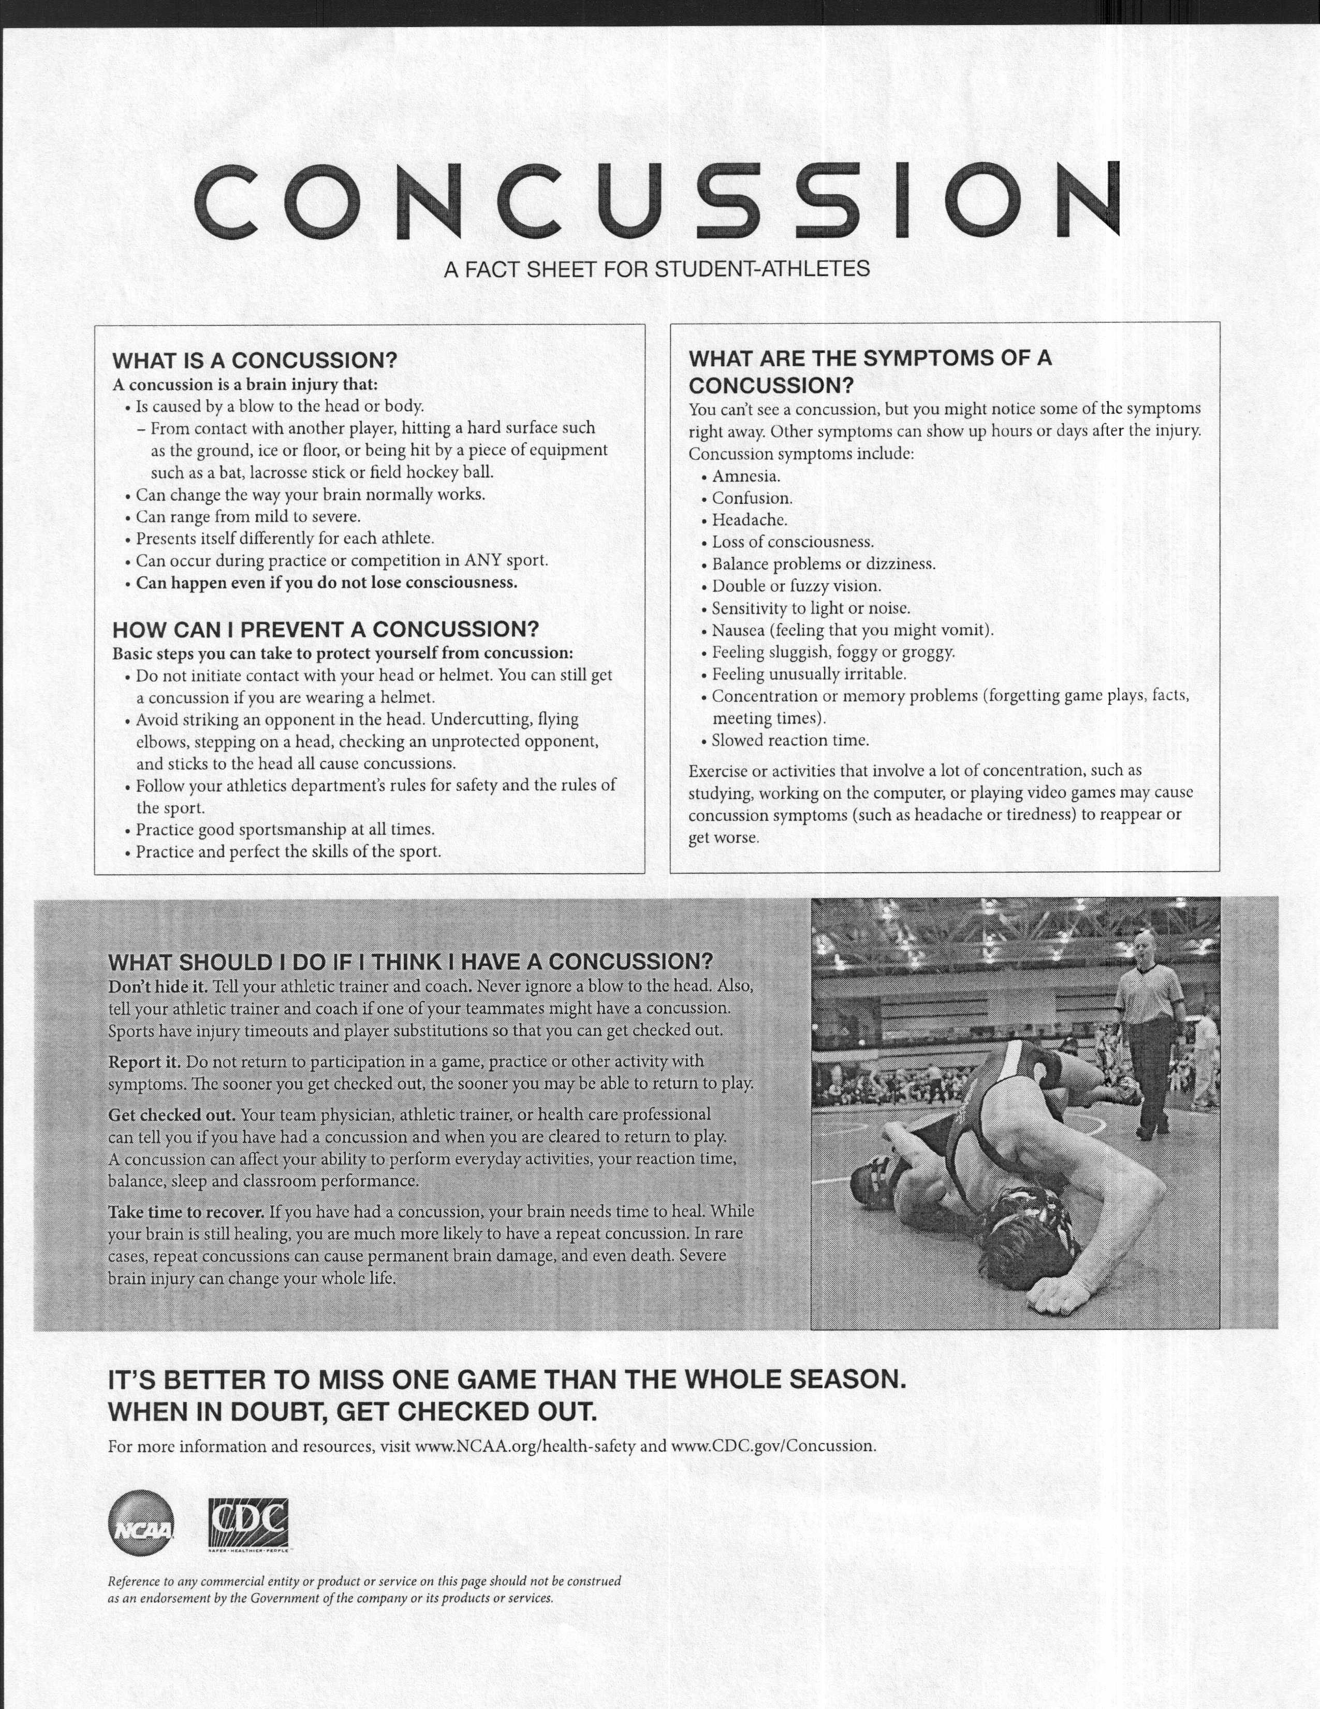
Attachment C

We will be using one of the educational videos endorsed by the National Athletic Trainers’ Association:

Football athletes will view the 12 minute video titled “Concussions in Football”
https://vimeo.com/15026404

All other athletes will view the 9 minute video titled “Concussions: Don’t Hide It, Report It, Take Time to Recover”
https://www.youtube.com/watch?v=T3FLRDxbLXg&t=1s

Handouts to be given:
CDC concussion sheet

Attachment D

9.6 Concussions (Adopted March 28, 2013; effective July 1, 2013.)

9.6.1 Institutions shall have a documented concussion management plan that reflects current standards and practices regarding concussion management.

9.6.2 Any student-athlete who exhibits signs, symptoms, or behaviors consistent with a concussion shall be removed from practice or competition and evaluated by the institution’s designated Athletic Medical Coverage Personnel as defined in Bylaw 9.2.2, trained in the evaluation and management of concussions. Signs and symptoms associated with concussions can be found in Appendix G.

9.6.3 Student-athletes determined to have a concussion shall not return to activity for at least the remainder of that day. Medical clearance shall be determined by a physician trained in the evaluation and management of concussions, or his or her designee, according to the institution’s concussion management plan.

9.6.4 All student-athletes shall receive educational material on an annual basis regarding the signs and symptoms of concussions in order to understand the responsibility to report such signs and symptoms, for themselves as well as teammates, to a member of the institution’s sports medicine team and coaching staff.

9.6.5 All coaches shall receive educational material on an annual basis regarding the signs, symptoms, and management of concussions. All coaches must understand their responsibility in referring any student-athlete with such signs and symptoms to the athletic trainer as described in the institution’s concussion management plan. It is recommended that the presentation of educational material and the institution’s concussion plan, to all coaching staffs, be held at the annual mandatory coaches’ compliance meeting. Examples of educational material can be found in Appendix G.

9.6.6 When a visiting student-athlete is suspected of sustaining a concussion and his or her respective athletic trainer is not present, it is the responsibility of the host athletic trainer to: communicate the nature of the concussion to the head coach and student-athlete, refer the student-athlete to his or her athletic trainer for follow-up care, and communicate the details of the injury directly to the athletic trainer responsible for follow-up care.

Attachment E Moorpark College Concussion/mTBI Assessment

Name:_________________________ Sport:__________ Date:__________ Time:__________ Cell #:_________________

Mechanism of Injury:_________________________________________________________________________________

LOC: Yes / No Length of time:__________ Prior History: Yes / No____________________________________________

Medications:________________________________ Heart Rate:_________ Blood Pressure:_________ Color:_________

Neurological Screening Recollection of Injury (pre or post-traumatic amnesia) Grip Strength: 5 4 3 2 1

Cranial Nerves:
1. Olfactory: smell +/- 5. Trigeminal: open, bite down, +/- 9. Glossopharyngeal: swallow +/-
2. Optic: read a sign, PEARL +/- face sensation 10. Vagus: talk +/-
3. Oculomotor: eye adduction, +/- 6. Abducens: lateral eye movement +/- 11. Accessory: shoulder shrug +/-
downward rolling & pupil reaction 7. Facial: smile & taste +/- 12. Hypoglossal: stick out tongue +/-
4. Trochlear: upward eye rolling +/- 8. Vestibulocochlear: hearing +/-

1. Orientation Month____ 0 / 1 Date____ 0 / 1 Day of week____ 0 / 1 Year____ 0 / 1 Time (w/in 1 hr)____ 0 / 1

Orientation Total Score ___/5
2. Immediate Memory
(All 3 trials are completed Trial 1: Trial 2: Trial 3:
regardless of score on trial Sherlock 0 / 1 0 / 1 0 / 1
1 & 2; total score equals sum Gold 0 / 1 0 / 1 0 / 1
across all 3 trials. Note: Subject is 8-3-57 0 / 1 0 / 1 0 / 1
not informed of Delayed Recall Moorpark 0 / 1 0 / 1 0 / 1
testing of memory.) Gus 0 / 1 0 / 1 0 / 1

Immediate Memory Total Score ___/15

3. Concentration
Digits Backwards 4-9-3 6-2-9 0 / 1
(If correct, go to next string 3-8-1-4 3-2-7-9 0 / 1
length. If incorrect, read 6-2-9-7-1 1-5-2-8-6 0 / 1
trial 2. Stop after incorrect 7-1-8-4-6-2 5-3-9-1-4-8 0 / 1
on both trials.)

Months in Reverse Order (entire sequence correct for 1 point)
Dec-Nov-Oct-Sept-Aug-Jul-Jun-May-Apr-Mar-Feb-Jan 0 / 1
Concentration Total Score ___/5

4. Delayed Recall
Sherlock 0 / 1
Gold 0 / 1 Summary of Total Scores
8-3-57 0 / 1 1. Orientation ___/5
Moorpark 0 / 1 2. Immediate Memory ___/15
Gus 0 / 1 3. Concentration ___/5
Delayed Recall Total Score ___/5 4. Delayed Recall ___/5
OVERALL TOTAL SCORE ___/30

Symptom Checklist
Date:
 |  | AT: | AT: | AT: | AT: | AT:
Rate symptoms from 0-6 (0 = none, 1 or 2 = mild, 3 or 4 = moderate, 5 or 6 = severe)
Headache
"Pressure in head"
Neck pain
Nausea or vomiting
Dizziness
Blurred vision
Balance problems
Sensitivity to light
Sensitivity to noise
Feeling slowed down
Feeling like "in a fog"
"Don't feel right"
Difficulty concentrating
Difficulty remembering
Fatigue or low energy
Confusion
Drowsiness
Trouble falling asleep
More emotional
Irritability
Sadness
Nervous or anxious
# OF SX/TOTAL SCORE | / | / | / | / | / | /

Balance Error Scoring System (BESS) [20 seconds each test, eyes closed, hands on hips, lower extremity @ 90/90]
Types of Errors: hands off hips, opening eyes, step, stumble, fall, >30˚ hip abduction, lifting forefoot or heel, out of position >5”
Dominant Leg: Right / Left Date:
 |  | AT: | AT: | AT: | AT: | AT:
Stable Surface
Double Leg Stance | ___/10 | ___/10 | ___/10 | ___/10 | ___/10 | ___/10
Single Leg Stance (non-dominant foot) | ___/10 | ___/10 | ___/10 | ___/10 | ___/10 | ___/10
Tandem Stance (non-dominant foot @ back) | ___/10 | ___/10 | ___/10 | ___/10 | ___/10 | ___/10
TOTAL | ___/30 | ___/30 | ___/30 | ___/30 | ___/30 | ___/30
Unstable Surface
Double Leg Stance | ___/10 | ___/10 | ___/10 | ___/10 | ___/10 | ___/10
Single Leg Stance (non-dominant foot) | ___/10 | ___/10 | ___/10 | ___/10 | ___/10 | ___/10
Tandem Stance (non-dominant foot @ back) | ___/10 | ___/10 | ___/10 | ___/10 | ___/10 | ___/10
TOTAL | ___/30 | ___/30 | ___/30 | ___/30 | ___/30 | ___/30

ImPACT Test: Yes / No Date:__________ Initial Evaluation By:___________________________________
Attachment F Moorpark College
HEAD INJURY WARNING INSTRUCTIONS

Name:_____________________________ Date:______________ Time:_________
Comments:__________________________________________________________________________________________________________________________________________________________________________
You have sustained an injury to your head and must be aware of the following symptoms. If they occur, notify your physician immediately or report to a local hospital emergency room.
- Blurred/Double or fuzzy vision
- Nausea/Vomiting/Sensitivity to light or noise
- Disorientation/Confusion/Amnesia/memory concentration difficulty
- Lethargy or emotional
- Severe progressive headaches (mild are expected)
- Increased drowsiness
- Difficulty arousing patient (the patient should be awakened every 2 hours during the first night).
- Slowness of pulse
- Stiffness of neck
- Drainage of blood or clear fluid from ear or nose
- Weakness of limbs or loss of coordination/balance difficulty
- Loss of consciousness/Convulsions/Seizures
- For the first 24 hours have a family member or friend observe you.
- Alcohol and/or pain medications or anti-inflammatories may increase or mask symptoms and should not be used until further evaluation – Tylenol ONLY may be taken if absolutely needed.
*DO NOT STAY ALONE OR SLEEP ALONE*
Emergency Phone Numbers: 911
Cherisse Meichtry Dr. Pierre Durand Health Center
Athletic Trainer Team Physician (805) 378-1413
(805) 378-1493 (805) 497-9481
(818) 337-8294 cell
-------------------------------------------------------------------------------------------------------------------------------
I have received and understand the home instructions for head injuries and concussions and will have a friend, relative or guardian accompany me home and monitor my symptoms for 24 hours.

Print Name: _____________________________ Date:__________________
Signature: ______________________________
If a minor, parent/guardian signature: __________________________
7/17

Attachment G

Concussion/mTBI Awareness Letter
The Moorpark College Athletic Training and Student Services/Academic Counseling Department would like to inform you that _________________________ sustained a concussion/mild traumatic brain injury (mTBI) during _________________ on ___/___/___/. He/she was evaluated by __________________, MD, team physician. ________________ will undergo additional concussion/mTBI testing today. A concussion or mTBI can cause a variety of physical, cognitive, and emotional symptoms. Concussions/mTBIs range in significance from minor to major, but they all share one common factor – they temporarily interfere with the way your brain works. We would like to inform you that during the next few weeks this student-athlete may experience one or more of these signs and symptoms:
Headache | Nausea
Balance Problems | Dizziness
Diplopia – Double Vision | Confusion
Photophobia – Light Sensitivity | Difficulty Sleeping
Misophonia – Noise Sensitivity | Blurred Vision
Feeling Sluggish or Groggy | Difficulty Concentrating
As a department, we wanted to make you aware of this injury and the related symptoms that the student-athlete may experience. Although the student is attending class, please be aware that the side effects of the concussion/mTBI may adversely impact his/her academic performance. Any consideration you may provide academically during this time would be greatly appreciated. We will continue to monitor the progress of this student-athlete and anticipate a full recovery. Should you have any questions or require further information, please do not hesitate to contact us.

Cherisse Meichtry, MS, ATC, PES  Athletic Trainer | Pablo Diaz  Athletics Counselor
cmeichtry@vcccd.edu  (805) 378-1493 | pdiaz@vcccd.edu  (805) 652-7779 ext. 51522
Thank you in advance for your time and understanding with this circumstance.

